Title or Task: |   

Description:

Files Required
Suitable for Classes: | AIT • Multimedia • Cert II IT • Cert II Bus
Area: | Technology & Enterprise
Teacher: | Mr Peter Faulks

Timeline

Date Due:
Task Brief: | In class lesson

Outcomes:

Items highlighted in yellow are tasks for you to complete
Items in Blue italics are help tips

These pages are designed to show you how to use software packages; various software updates may have taken place so some pages will not apply to versions other than those listed here. In some cases data files may be required.

Create a Tab Menu
Create a better looking menu using tabs or indents, (use at least one Left tab and one decimal tab) add some graphics, colour, balance and presentation skills for either or both of the following menus:- Put each menu on a separate page print them out and hand in for marking.

Using Tabs
Click here to change tabs Click in here to place tab

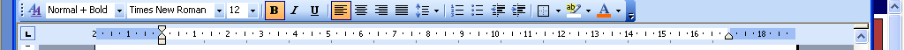
to remove a tab click on it and drag it onto your page
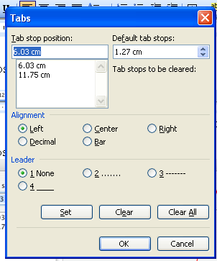
You can add lines to tabs click on
Format … Tabs… add leader or line
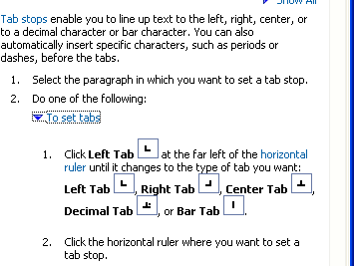

The Tabs

Hanging Indents Select the paragraph the move the hanging indent forwards or backwards

Windows Indent by moving the top triangle forward or back text is indented

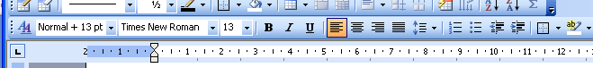

The square moves both bottom indents
_________________________________________________________________
Mac Indent by moving the top triangle forward or back text is indented

Select this paragraph change the indent (the square moves both bottom indents)

Bill Gates recently gave a speech at a High School about 11 things they did not and will not learn in school. He talks about how feel-good politically correct teachings created a generation of kids with no concept of reality and how this concept set them up for failure in the real world. Try it now with the rules paragraphs hit the tab key to move text).

Rule 1: Life is not fair - get used to it!
Rule 2: The world won't care about your self-esteem. The world will expect you to accomplish something BEFORE you feel good about yourself.
Rule 3: You will NOT make $60,000 a year right out of high school. You won't be a vice-president with a car phone until you earn both.
Rule 4: If you think your teacher is tough, wait till you get a boss.

A "restaurant" menu
PLEASE PLACE YOUR FOOD ORDER AT THE BAR

Fresh Crusty Italian bread
$3.00
Soup of the day with Turkish bread
$8.00
Hand cut potato chips with sweet chilli and sour cream
$7.00
Albany Mussels steam opened with lemon grass, ginger, cilantro, tomato and chilli
$14.50
Homemade beef and bacon burger char grilled with gouda, mustard pickle and aioli
$14.50
Turkish bread, steak sandwich with grilled onions, tomato, salad leaves and barbeque sauce
$15.00
Beer battered Snapper Fillet with fried capers, mushy peas, tartare, and hand cut chips
$14.50
Navarin braised lamb shanks with hearty winter vegetable stew
$16.50
Scotch fillet steak cooked on the coals, with choice of butters, on herb mash
(Garlic, Sun dried tomato, Thai and Herb)
$19.50
Chicken Rogan josh with spiced onions, basmati rice, poppadums and riata
$15.50
Mediterranean vegetable frittata over warm salad of butter pumpkin, balsamic onions and Swiss chard
$13.00
The Cut salad sun dried tomato, kalamata olives, spanish onions, haloumi, peppers salad leaves, balsamic and extra virgin olive oil
$7.50

"your name's" All Day Menu
Starters

Soup of the Day
served with Crusty Roll
6.00
Garlic Mushrooms on Brioche Toast
6.50
Chargrilled Vegetable Salad with Chilli Salsa
6.50
Potted Salmon with Country Bread
7.50
Bruschetta of Tomato, Mozzarella and Parma Ham
4.00
Main Course

Thai Green Chicken Curry
with Rice and Fresh Coriander
9.00
Cumberland Sausage
with Champ Potatoes and Onion Gravy
9.00
Broccoli and Brie Tart
7.50
Stir Fried Beef with Sweet Peppers, Mange Tout and Oyster Sauce
with Steamed Rice
9.50
Smoked Cheese, Chive and Tomato Risotto
8.00
Pan Fried Liver
with Black Pudding, Caramelised Onion and Bacon Mash
8.50
Fish

The Restaurant's Salmon Fishcakes
8.00
Tempura of Plaice
with a Sweet Chilli Dip
9.00
Poached Salmon
with Crushed New Potatoes and Herb Mayonnaise
9.50
Salads

Chicken Caesar Salad
7.00
Greek Salad with Toasted Garlic Bread
6.00
Warm Salad of Black Pudding, Bacon and Mushroom with a Poached Egg
7.00
Side Orders

Tossed Salad / Mixed Vegetables / Fries / New Potatoes / Rice
3.00
Pasta

Penne with Roasted Garlic and Chargrilled Vegetables
8.00
Spaghetti, coated with a Bacon and Garlic Cream Sauce
with herbs and Parmesan
8.50
Desserts

Sticky Toffee Pudding
4.50
White Chocolate Cheesecake
5.00
Peacan Pie with Cream
5.00
Raspberry Syllabub
4.50
Classic Lemon Tart
4.50
Drinks

A wide range of hot and cold beverages are available

Save the work



